This is an abstract for the Regenerative Universe manuscript by Rob Messick that was in process up to 2017
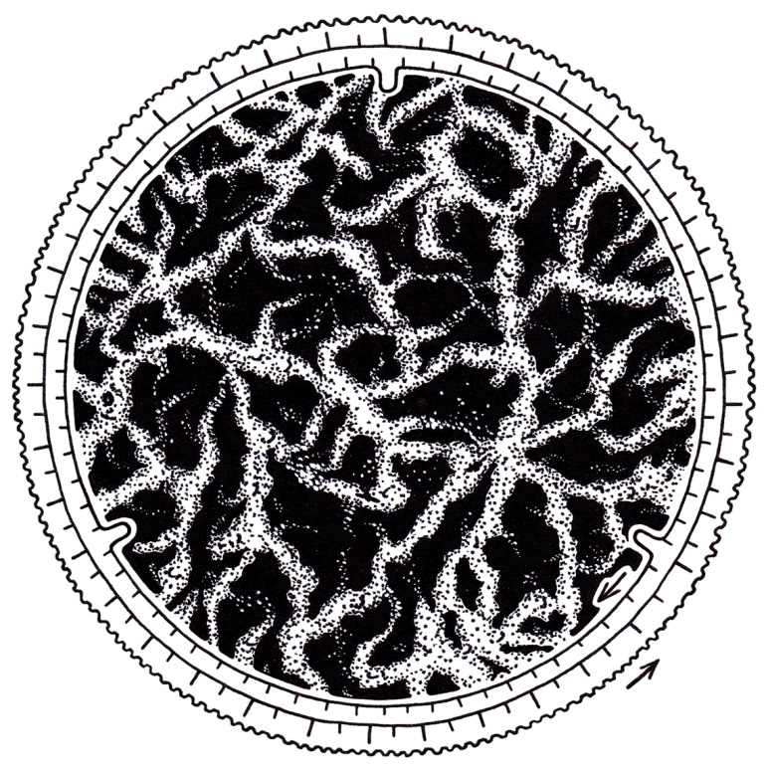
Abstract
A synthesis approach to cosmology is demonstrated based on regeneration, fifteen reasonable states of matter, and a comprehensive understanding of energy transfer among microstates that includes matter in: a) molecular scale interactions, b) atomic scale interactions, c) particle, wave, and field scale interactions, and d) an integration of previous theories about quantum unit scale that could include paired elements. Eight universals are proposed that include matter in motion, an entropy and syntropy based thermodynamics, multiple state fluid dynamics, the ubiquity of the plasma state of matter, three strong conservation patterns, scale invariant and common forms, direct and inverse relationships of many types, and three or more significant thresholds of behavior in microstates (as alluded to above). A diffusion and recollection hypothesis is formulated that deals with critical exponents in the universe and integrates six measurable properties of matter and energy including space, time, energy, fields, density, and mass (STEFDM). A theory that is based on matter power spectrums, plasma scaling, recycling of microstates, and recurring gradient differentials is proposed as a replacement for the linear-cosmogony of the big bang theory. The regenerative alternative includes measurable ranges of energy density, current density, and matter density as central themes. Electromagnetism, gravity, and strong and weak nuclear forces are put in a clearer context by this process.

Scenarioscope illustration by RM (with dials and zoom-in capacity inspired by “The Race for Absolute Zero”, Nova, 2010

